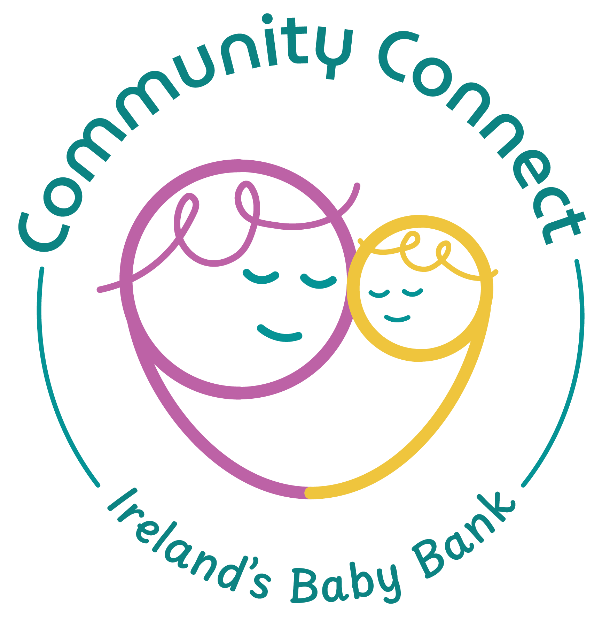

Community Connect Support clg
Donor Charter

Feb 2026

As a charity seeking donations from the public, we in Community Connect aim to comply with the Guidelines for Charitable Organisations on Fundraising from the Public.
Community Connect pledges to treat all our donors with respect, honesty and openness. We commit to being accountable and transparent so that donors and prospective donors can have full confidence in Community Connect.
Community Connect commits that you, our donors and prospective donors will:
- Be informed of the organisation’s Vision, Mission and Values, and of the way the organisation intends to use donated resources.
- Be informed of the identity of those serving on the Board of Directors, and that the Board will exercise prudent judgement in its stewardship responsibilities.
- Receive appropriate acknowledgement and recognition.
- Have your right to privacy respected.
- Expect that all relationships with individuals representing the charity will be dealt with professionally.
Community Connect will:
- Provide access to the organisation’s most recent financial statements, when available.
- Ensure that information about your donation is handled with respect and with confidentiality to the extent provided by law.
- Inform donors whether those seeking donations are volunteers, employees of the organisation or hired third party agents.
- Make agreed procedures for making and responding to complaints easily available on our web site.
- Ensure that any requests for any names to be deleted from mailing lists are carried out promptly and inform donors and supporters if the organisation intends to share the mailing lists with third parties.
- Provide prompt, truthful and forthright answers to questions they receive regarding the organisation.

