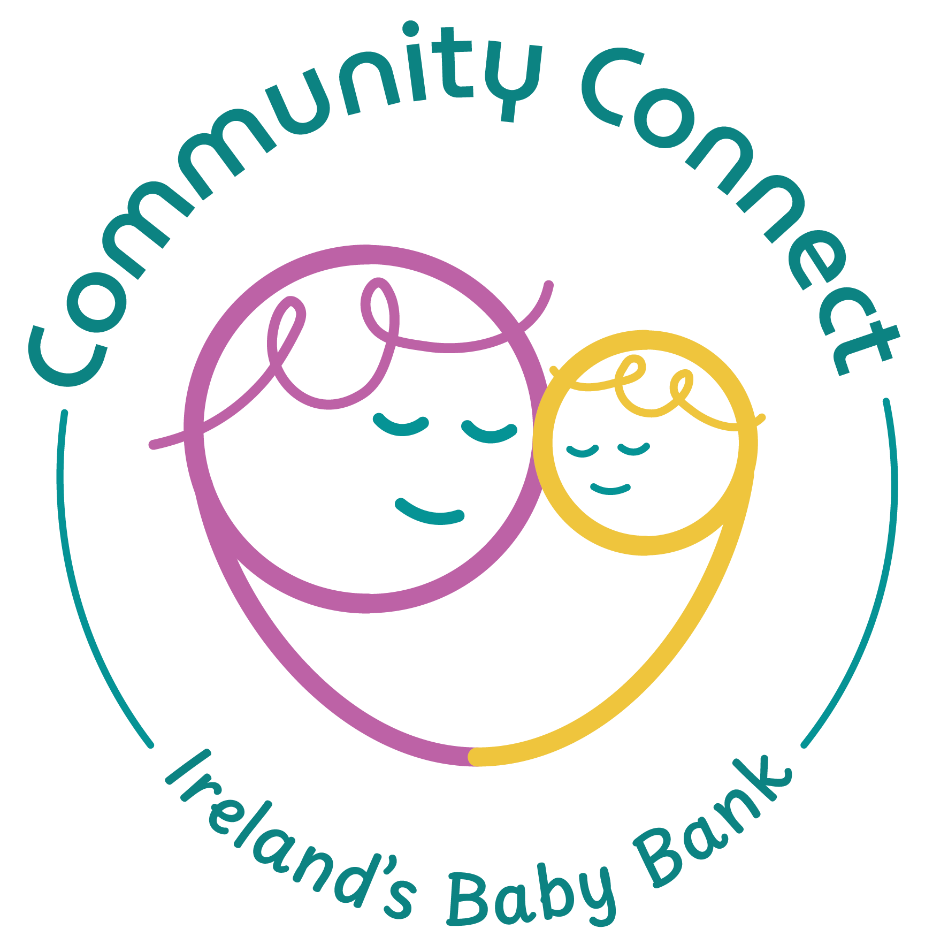

Community Connect Support clg
Complaints Policy

Feb 2026

- Purpose
Community Connect is committed to ensuring that all our communications and dealings with the general public and our supporters are of the highest possible standard.
We listen and respond to the views of the general public and our supporters so that we can continue to improve. Community Connect is committed to resolving your complaint as quickly as possible.
We are committed to being consistent, fair and impartial when handling your complaint.
This policy has been designed to provide guidance on the manner in which Community Connect receives and manages complaints. Community Connect welcomes both positive and negative feedback.

- Objective
Community Connect’s aim is to ensure that:
- It is as easy as possible to make a complaint.
- You are aware of our complaint lodgement and handling processes.
- Both you and our staff and volunteers understand our complaints handling process.
- We learn from complaints, use them to improve, and monitor them at our Board.
- We respond accordingly – for example, with an explanation, or an apology where we have got things wrong and with information on any action taken etc.
Any complaint will be:
- Investigated impartially with a balanced view of all information or evidence.
- Considered on its merits, taking into account individual circumstances and needs.
- Treated seriously whether it is made by telephone, letter, email or in person.
- Dealt with quickly and politely.
- Definition of a Complaint
In this policy, a complaint means an expression of dissatisfaction by a member of the public relating to any service provided by Community Connect.

- How a Complaint can be Made
If you are dissatisfied with the service provided by us, you should in the first instance consider speaking directly with the staff member/s or volunteer/s you have been dealing with. If you are uncomfortable with this or believe the relevant staff member or volunteer is unable to address your concerns, you can lodge a complaint with us in one of the following ways:
- By phoning us on 085 875 8366
- By writing to our CEO, Elaine Noonan at: Community Connect, Clifton House, Fitzwilliam St Lwr, Dublin 2
- By emailing us at info@communityconnect.ie
- In person by speaking to any of our management or staff

Anonymous complaints will not normally be investigated as there is always a possibility that they are malicious, and the anonymity of the complainant does not enable the principles of natural justice and procedural fairness to be upheld. In particular, anonymous complaints about an employee or a volunteer of Community Connect cannot be investigated as this is contrary to the rights of the employee or volunteer concerned.

- Information Required to Support a Complaint
When we are investigating a complaint, we will be relying on information provided by the person making the complaint and information we may already be holding. We may need to contact you to clarify details or request additional information where necessary. To help us investigate your complaint quickly and efficiently we will ask you for the following information:
- Your name and contact details
- The nature of the complaint
- Details of any steps you have already taken to resolve the complaint
- Copies of any documentation which supports the complaint
- Details of conversations you may have had with Community Connect that may be relevant to the complaint

- Recording Complaints
When taking a complaint, we will record your name and contact details. We will also record all details of your complaint including the facts and the cause(s) of your complaint, the outcome and any actions taken following the investigation of your complaint. We will also record all dates and times relating to actions taken to resolve the complaint and communications between us.
On an ongoing basis, complaints will be monitored for any identifying trends by management and rectification/remedial action taken to mitigate any identified issues. If you lodge a complaint, we will record your personal information solely for the purposes of addressing your complaint. Your personal details will actively be protected from disclosure, unless you expressly consent to its disclosure.

- Feedback
Community Connect is committed to resolving your issues at the first point of contact, however, this will not be possible in all circumstances, in which case a more formal complaints process will be followed. We will acknowledge receipt of your complaint within seven (7) business days. Once your complaint has been received, we will undertake an initial review of your complaint. There may be circumstances during the initial review or investigation of your complaint where we may need to clarify certain aspects of your complaint or request additional documentation from you. In such circumstances, we will explain the purpose of seeking clarification or additional documentation and provide you with feedback on the status of your complaint at that time. We are committed to resolving your complaint within one month of you lodging your complaint, however, this may not always be possible on every occasion.
Where we have been unable to resolve your complaint within one month, we will inform you of the reason for the delay and specify a date when we will be in a position to finalise your complaint. During the initial review or investigation stage we may need to seek further clarification or documentation from you to assist us in resolving your complaint. If we have sought clarification or additional documentation from you and we are waiting on you to provide this information, we may not be able to meet our commitment to finalising the complaint within one month. In such circumstances, upon receipt of your clarification or additional documentation we will indicate to you when we expect to be able to finalise your complaint.
Once we have finalised your complaint, we will advise you of our findings and any action we have taken. We will do this in writing, unless it has been mutually agreed that we can provide it to you verbally. You have the right to make enquiries about the current status of your complaint at any time by contacting us.

- Complaints about Community Connect Employees or Volunteers
If you complain about a member of our staff or volunteer, we will treat your complaint confidentially, impartially and equally (giving equal treatment to all people). We will investigate your complaint thoroughly by finding out the relevant facts, speaking with the relevant people and verifying explanations where possible.
We will also treat our staff member or volunteer objectively by:
- Informing them of any complaint about their performance
- Providing them with an opportunity to explain the circumstances
- Providing them with appropriate support
- Updating them on the complaint investigation and the result

- Complaints Escalation Process
If you are not happy with our response, you may get in touch again by writing to the Community Connect Chairperson: James Condren.
The Chairperson will ensure that your appeal is considered at Board level and will respond within 4 weeks of this consideration by Board members. Write to: Chairperson, Community Connect, 24a Baggot St Upper, D04 N528.
Or if you are not satisfied with the manner in which the complaint is handled by us and would like to contact an external organisation, you have the right to raise a concern with the Charities Regulator of Ireland.

